UI/UX Internship

Name : - Harish B

Date : - 18/03/2024

Institute :- CODSOFT

Task 01 - Mobile App Signup flow

Prototype Link: - <https://www.figma.com/proto/xr5iqF9gBaCXs1Wq50e0Vg/Untitled?page-id=26%3A1241&type=design&node-id=26-1313&t=Yie2ggsWOUpcPZYr-0&scaling=min-zoom>

**Output Images: -**

 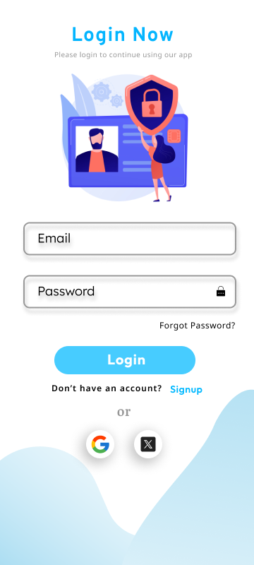

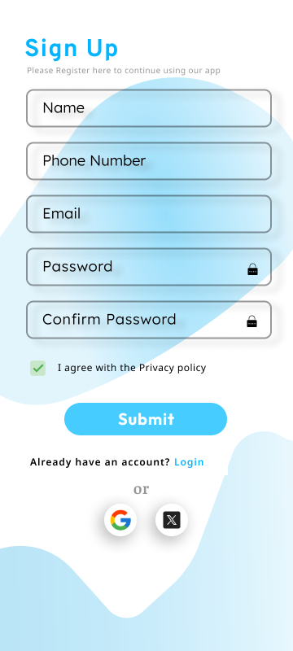

Task 02 - Email Template

**Output Images: -**



Task 03 – E-commerce Website Desktop view

**Output Images: -**

